**Title:** Bangladesh Premier League T20 Cricket Match Outcome Prediction Using an Ensemble Learning Approach

**Abstract:** Predicting the results of cricket matches, especially in the fast-paced Twenty20 (T20) format, is a significant challenge in sports analytics. This paper presents a comparative study of machine learning models for predicting match outcomes in the Bangladesh Premier League (BPL). We evaluate the performance of three advanced ensemble models— Random Forest, Gradient Boosting, and XGBoost—against a single Decision Tree baseline. Using a comprehensive historical dataset spanning from the 2012 to 2024 BPL seasons, our approach incorporates richly engineered features, including team form metrics and venue-specific dynamics, alongside core match attributes. The models were rigorously evaluated using 5 fold cross-validation. The results demonstrate the superiority of ensemble techniques, with Gradient Boosting and XGBoost achieving the highest mean accuracies of 97.73% and 97.70%, respectively, significantly outperforming the baseline model. These findings underscore that a combination of sophisticated feature engineering and advanced ensemble algorithms is crucial for capturing the complex, non-linear dynamics of T20 cricket. The framework provides a valuable tool for teams, analysts, and fans, laying the groundwork for more accurate predictive systems in the future.

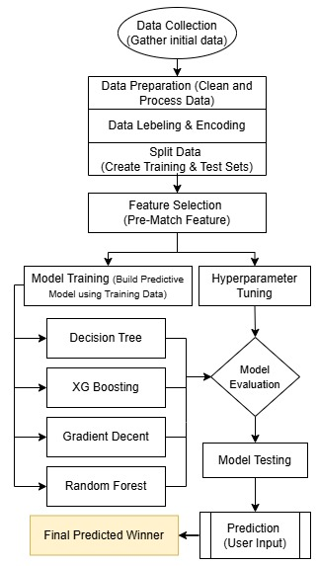

Figure: Research Methodology

**Keywords:** machine learning, live cricket match prediction, BPL T20, historical BPL match data, ensemble models.